​​

Video conference case study

Build a video conferencing WebApp. Use React for frontend and Node to build backend server. You can use MySQL as a database.

1. Create a basic login page with a signup option. SignUp page will onboards Hosts. Assume basic details like name, email, password.
2. Build Host view page (refer attached image for design). On login Host will be redirected here.
3. Create a unique link with which Participants can join the conference. This is a sharable link so add a “Share link” button in the UI.
4. Build a Participant view page (refer attached image for design). When a Participant opens the shared link in the browser this page should open up.
5. Before entering, ask for the Participant Name in a dialog box. This name will appear in the Host view page.
6. When the Host clicks on the timer (15 sec, 30 sec, 45 sec, 60 sec etc) there should be a countdown timer displayed on the Participant page. The timer should refresh every second and should be on the screen till it reaches 0. Once the timer reaches 0, it should play any sound.
7. Build an additional feature of “Raise hand” where during a session if a Participant clicks on a “Raise hand” button the Host should see on UI that the Participant has raised hand.
8. Please use websockets to communicate between Host and Participants.

Bonus:

1. If you Dockerize individual services.
2. Add additional functionality of creating Conference sessions with scheduling feature.  
   NOTE: You will have to get creative and build a UI by yourself.
3. Build a Conference sessions stats page. Essentially when the conference is finished, if I click on stats I should be able to see list of participants, session time, timer counters used during session.

Technologies/libraries/languages to use: React, NodeJs, Typescript, MaterialUI

***Please note:*** You don't need to integrate the actual video streaming API. You just need to build the pages and a server to send the timer details to the participants.

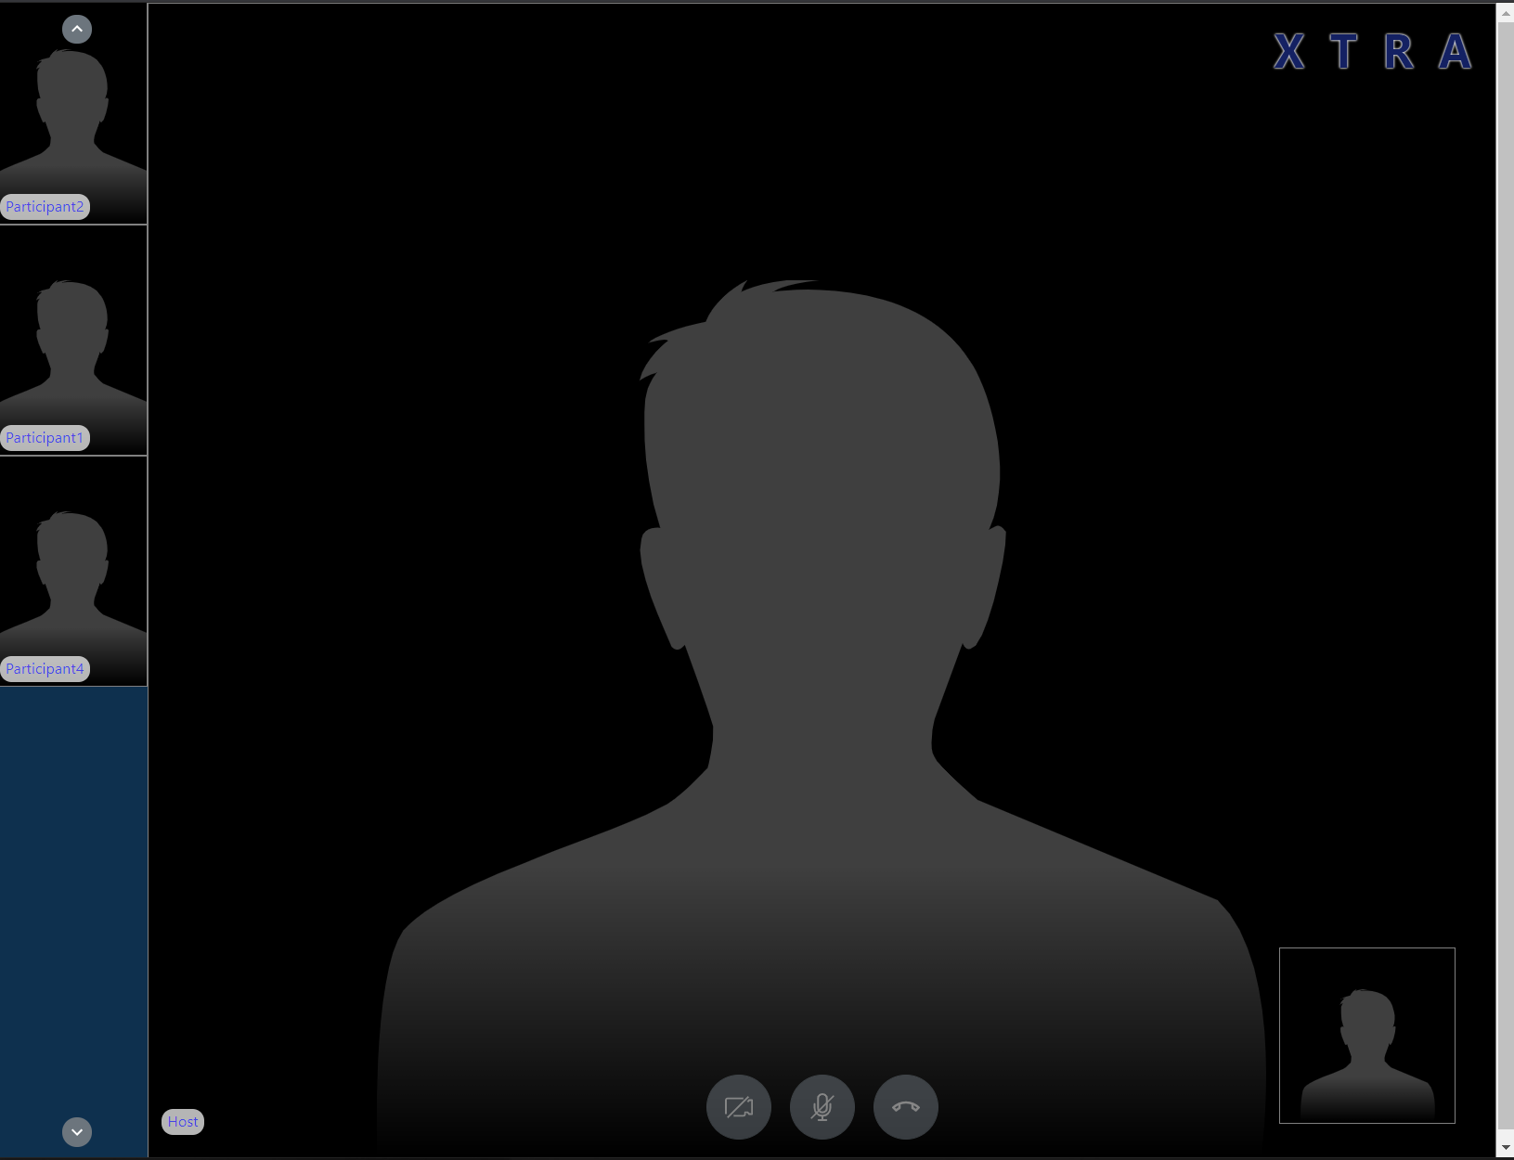

participant view

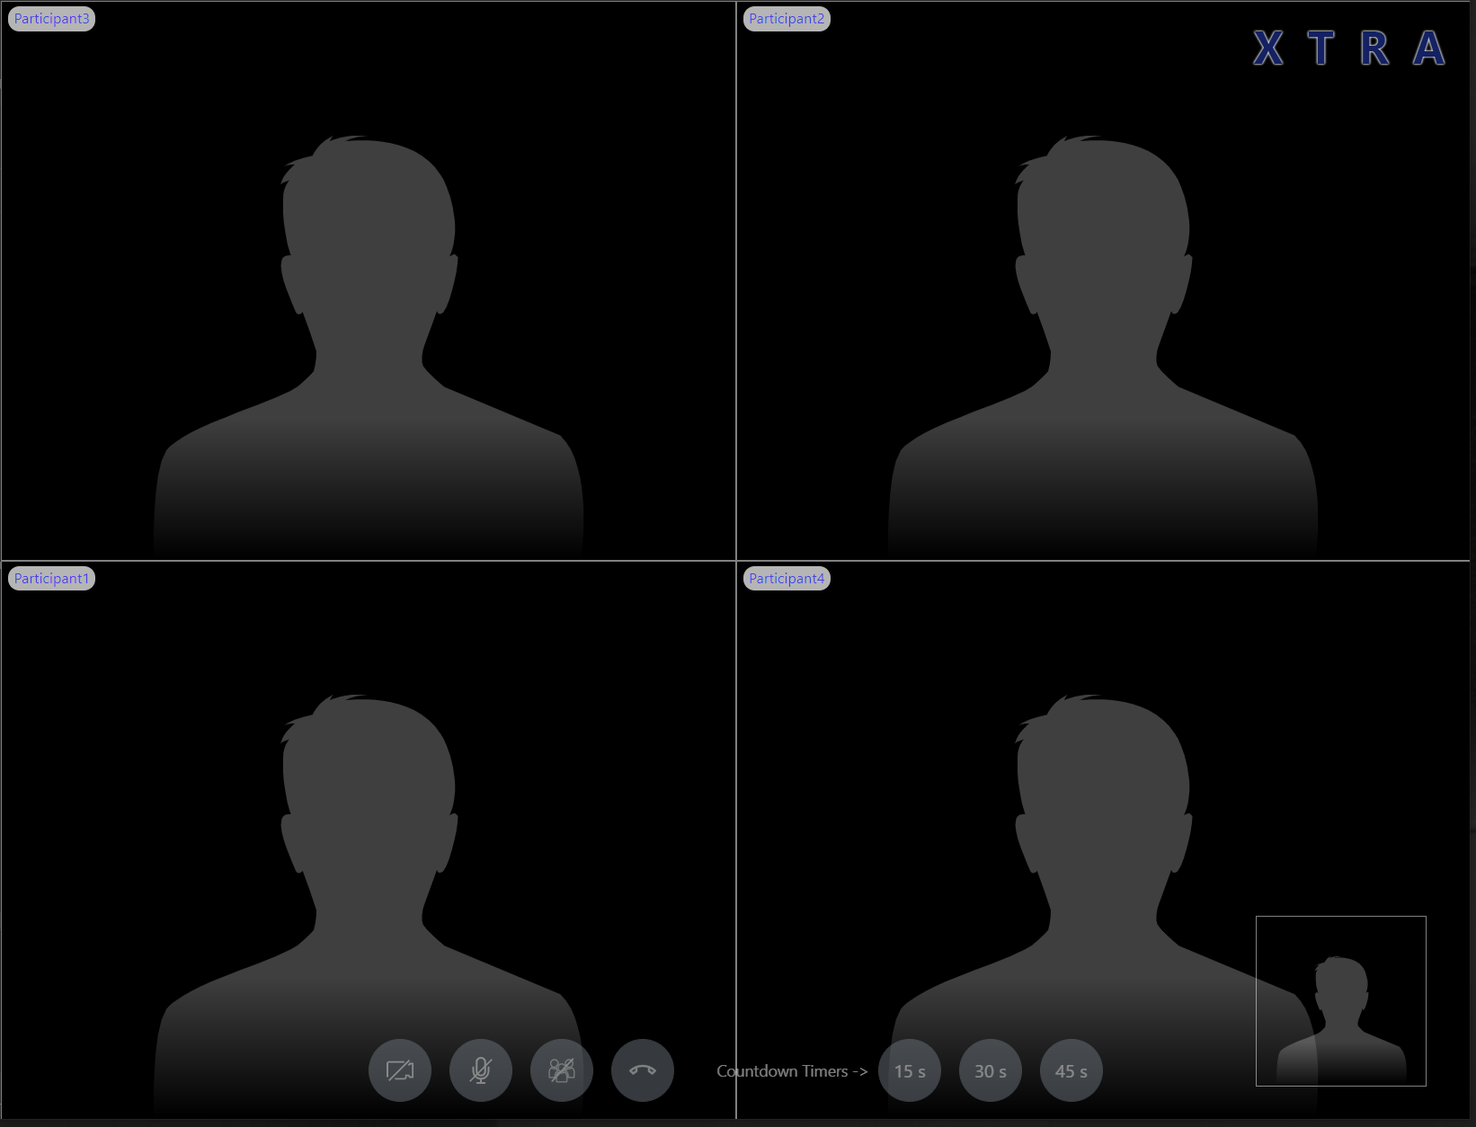

Host View